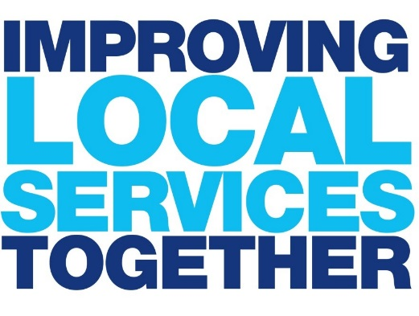

# Making Involvement Happen

## **An introduction to User Involvement**



**Contents**

|  |  |
| --- | --- |
| GETTING STARTED | 3 |
| **STAGE 1: PLAN** |  |
| ENGAGEMENT APPROACHES | 4 |
| EXAMPLE USER INVOLVEMENT WORK PLAN | 7 |
| ENGAGEMENT EVENT – BEFORE YOU RECRUIT | 10 |
| EXAMPLE ROLE DESCRIPTION | 12 |
| EXAMPLE TERMS OF REFERENCE | 14 |
| **STAGE 2: RECRUIT** |  |
| RECRUITING MEMBERS OF AN ONGOING GROUP | 16 |
| EXAMPLE APPLICATION FORM | 17 |
| EXAMPLE TELEPHONE INTERVIEW FRAMEWORK | 20 |
| EXAMPLE RECRUITMENT PLAN | 22 |
| EXAMPLE RECRUITMENT FLYER | 26 |
| **STAGE 3: DELIVER** |  |
| EXAMPLE FACILITATION PLAN FOR AN ENGAGEMENT EVENT | 27 |
| OTHER EXAMPLES OF SESSION STRUCTURES | 31 |
| EXAMPLE TELEPHONE INTERVIEW FRAMEWORK | 32 |
| CHECKLIST FOR AN ENGAGEMENT EVENT | 34 |
| EXAMPLE EVALUATION FORM FOR ENGAGEMENT EVENT | 36 |
| **STAGE 4: REVIEW** |  |
| FINDINGS REPORT FOR A USER INVOLVEMENT ACTIVITY – EXAMPLE STRUCTURE | 38 |
| EXAMPLE FEEDBACK FOR PATIENTS | 41 |
| CASE STUDIES – USER INVOLVEMENT IN DIABETES SERVICES | 42 |

# Getting Started

This workbook was developed by Diabetes UK as part of its Improving Local Services Together (ILST) project. The ILST project ran from 2012 to 2014.

The workbook provides a range of practical tools and techniques to support individuals and organisations to meaningfully involve people with diabetes in the planning, design, delivery and evaluation of diabetes services.

The first step to user involvement is setting a service improvement goal to focus your work.

## **Service Improvement Goal**

|  |
| --- |
|  |
|  |
|  |
|  |
|  |
|  |
|  |
|  |
|  |
|  |
|  |
|  |
|  |
|  |
|  |
|  |
|  |
|  |
|  |
|  |
|  |
|  |

Be clear on what part of your service you are trying to improve, and identify a goal that is specific and measurable:

Stage 1 Plan

**Engagement Approaches**

| **Approach** | **Explanation** | **Benefits** | **Pitfalls** |
| --- | --- | --- | --- |
| **Engagement events** | An event based in the local community with 15-30 participants. Participants tend to work in small groups on set discussion topics, although whole group discussions can also be used. An excellent way to generate broad discussions with a wide range of people.  1 or 2 lead facilitators required, with extra support for facilitating table discussions. | * You will hear from a wide range of people, which will generate lots of discussion and lots of ideas * You can use a range of activities within this including individual reflection, pair work, small group work, whole group discussions. Where appropriate, you can also use techniques such as a world café. | * Some people are less comfortable speaking out in large groups * Whoever shouts the loudest gets heard! * Reliant on good facilitation otherwise subgroups may appear and individuals dominate * Can be difficult to capture really detailed notes. Often reliant on participants to capture discussions. |
| **Focus groups** | Small groups of 8-12 people, focusing on a specific issue or topic.  Can be helpful for speaking to hard-to-reach groups if you are struggling to engage with them at wider community events.  1 lead facilitator and a note taker required. | * Can generate very detailed discussions and allows for detailed note capturing * Allows everyone the chance to have their say and be heard * Opportunity to hear from a range of individuals with diverse experiences | * Dominant characters can take over if not managed well * Allows people to be influenced by the opinions of others |
| **Interviews** | A one-to-one meeting (or a very small group discussion) designed for a specific objective. | * Good for building rapport * Easier to obtain individual perspectives and ensure everyone gets a chance to have their say * Some people are more comfortable sharing their opinions in a one-to-one setting than a group setting * Can generate very detailed feedback | * Time intensive to capture the views of lots of different people |
| **User/Reference Groups** | User or Reference Groups are ongoing advisory groups of a selected small group that meet over a period of time for the purpose of achieving specific objectives – and should link into decision making groups. A relatively formal recruitment process is usually used and the membership is selected to represent different elements of the local population.  Requires ongoing staff commitment to support, facilitate and administer the group. Good facilitation is important. | * Helps build a sense of partnership and gives people a sense of ownership * Creates the opportunity for ongoing, meaningful involvement | * The role suits a certain type of person * Involves a high level of commitment and time from both participants and staff managing the group |
| **Patient Representatives** | Two or three service users are selected to be representatives of the larger population. They sit on decision-making groups alongside professionals.  Requires ongoing support and training, if necessary. | * Adds a service user perspective right where decisions are made * Encourages partnership working | * The role suits a certain type of person. They will need some familiarity of attending formal meetings and have the confidence to share their views * Can be seen as tokenistic by both professionals and service users |
| **Online networks** | A network of people who are willing to be engaged with in an ad-hoc way, mainly via email. These people can also be invited along to focus groups etc. as appropriate. | * An efficient and cost-free way of keeping in regular contact with people and maintaining relationships with those who want to be engaged in an ongoing way. | * Excludes those who are not comfortable using computers * Can be tokenistic, should not be used as the only approach to engaging service users |
| **Questionnaire** | Gathering feedback via survey – either online or on paper. Questions can also be asked in person or over the phone. | * Useful for accessing/collecting larger amounts of feedback * Data is often easier to analyse * Online surveys can be cost free * Can be a quicker form of engagement – both for service provider and service user | * Usually information gathered is not very detailed * Involvement can be more passive than other methods * Feedback rather than dialogue can mean that it is harder for the method to influence decisions |

**Example user involvement work plan**

| **Action** | **Date** | **Budget?** | **Lead** | **Comments** |
| --- | --- | --- | --- | --- |
| **Hold 2 patient events in the CCG area** | | | | |
| Finalise the purpose of the event | 23rd November 2012 | N/A | Mansfield & Ashfield | Some things we discussed were to find out:   * How aware people are that they should be receiving foot checks * Their experiences of receiving them * How often do they see their GP re: diabetes * Were they offered structured education on diagnosis |
| Book date and venues for each event | Early December 2012 | Venue and refreshments costs | Mansfield & Ashfield | Ensure venues are accessible and community based to encourage attendance. Suggestion to hold events in March, consider appropriate times. Venues should have a capacity for up to 50, and should be laid out cabaret style with room to move around |
| Develop a recruitment plan | End of December 2012 | N/A | DUK | DUK to draft a plan to target the whole diabetes population, making use of existing strong contacts in the area e.g. CVS, PPG’s |
| Deliver the recruitment plan | January – March 2013 | Some small printing costs | Mansfield & Ashfield (with contributions from DUK) |  |
| Manage booking and enquiries for the event | Ongoing | N/A | Mansfield and Ashfield | DUK can help to draft some copy to be used in providing more information in response to queries |
| Finalise the main discussion points for the events | January 2013 | N/A | DUK/ Mansfield and Ashfield |  |
| Agree the format of the event and design a facilitation plan | February 2013 | N/A | DUK to draft | To develop effective ways of covering the agreed discussion points |
| Prepare event resources | February 2013 | Some small costs | Mansfield and Ashfield | To include evaluation forms (DUK can provide), pens, paper etc. |
| Hold a short staff development session prior to holding the events | March 2013 | N/A | DUK | An opportunity for DUK to lead a short session for identified staff, offering advice on facilitating ahead of the event, and a run-through of the facilitation plan, if appropriate |
| Hold the events | March 2013 | Some expenses | Mansfield and Ashfield/ DUK | This could also be used to identify people who have had foot problems in the past who may want to be involved further in the project |
| Report findings of the events to the Diabetes Work stream meeting group | April 2013 | N/A | Mansfield and Ashfield | To help inform the group of what patients think future services should look like |
| Feedback to attendees on the outcomes of the event | April 2013 | N/A | Mansfield and Ashfield | Need to be clear on how the user contribution is going to be used to inform the next steps |
| Hold an internal review of the event | April 2013 | N/A | Diabetes UK/ Mansfield and Ashfield | A partnership review of what worked well/didn’t work well and the next steps |
| **Undertake some focused work on the experiences of people who have had foot problems** | | | | |
| Finalise the purpose of the focus group/s | May 2013 | N/A | Diabetes UK/ Mansfield and Ashfield | The number of focus groups to be held needs to be decided (this will be dependent on the need as well as expected interest |
| Set dates and venues for the focus groups | May 2013 | Venue and refreshment costs | Mansfield and Ashfield | Possibly use GP Surgeries |
| Draft recruitment plan | May 2013 | N/A | DUK | Make use of local GP’s to target people who have had foot problems |
| Deliver the recruitment plan | May-June 2013 | Some small printing costs | Mansfield and Ashfield |  |
| Design facilitation plans for the focus groups | June 2013 | N/A | DUK |  |
| Hold the focus groups | July 2013 | Expenses for participants | Mansfield and Ashfield |  |
| Collate and report findings from groups, report to Diabetes work stream group | July 2013 | N/A | Mansfield and Ashfield | Use the findings to inform the re-design of the foot care pathway |

**engagement event – before you recruit**

The following suggestions are important to consider during the initial planning of an engagement event, they may be obvious but will help to ensure that your event runs smoothly. Think about each section in the context of your objectives and the profile of people you want to come to your event; for example if you’re trying to speak to people of a working age, don’t organise an event for the middle of the day on a week day.

**VENUES**

It is often helpful if it is somewhere that will be familiar to people, for example, a local community centre or library. Churches and other religious centres often have suitable halls; however, think carefully about who you are trying to get to come along. Will they be put off? Some hospitals and other NHS buildings have very affordable rooms for hire, but again think about whether people will be put off by having to come into a hospital which they may have negative associations with.

The room itself may need to have the space to move tables around, especially if you want to do some breakout sessions. Plenty of natural light is also important. Also bear in mind that people may be hard of hearing so check out the acoustics prior to the event and make sure you book it for an hour before and after to set up and clear up.

The venue should also be fully accessible by public transport and, if possible, have parking available. It also needs to be fully accessible for disabled people or people with mobility issues, you should be particularly aware of this if you are running an event in relation to access, for example foot care.

**TIMINGS**

Consider how long it will take participants to travel to and from the venue. It is best if participants do not have to travel in rush hour, so think about starting the event late morning and finishing by mid-afternoon. It’s also worthwhile considering a Saturday session as we have found these to be well attended, though be conscious not to take up their whole weekend! You will also need to think about how your start and finish times will affect who is able to attend the session. For example clashes with school-run times may affect parents; sessions during the day will mean less people of a working age being able to attend. If you are planning on holding more than one session you should try and vary the times and days of them to allow different groups to engage and give people a choice.

The length of the event depends on what you want to get out of it and the kind of event you are running. For example, shouldn’t hold a focus group for longer than a couple of hours as they can be intense. For an engagement event, on the other hand, allow yourself enough time to get through what you need to without rushing – things will take longer than you expect! Ensure there are comfort breaks built in. However, long sessions may put people off so try and strike the right balance. Also be aware that people with diabetes may need to have set meal times so be wary of holding meetings over meal times - if you do make sure you provide appropriate food and that people are aware that you are providing it.

**INCENTIVES**

It is worth considering if you can provide some kind of incentive for people to attend, which you can highlight when asking people to come. This doesn’t need to be monetary, though offering vouchers or to cover travel expenses can be persuasive – but even simple things such as refreshments and leaflets can motivate people to attend. Generally people really appreciate being given information so provide relevant literature where possible (you can order some for free from shop.diabetes.org.uk).

**ONGOING USER GROUPS**

Depending on the type of activity you are arranging, you may also need to prepare some additional materials. For example if you are trying to establish an ongoing user group, then you should consider putting in place role descriptions for its members and terms of reference for the group as a whole to ensure the group fits your needs. On the following pages are examples of both documents:

### **Example role description – For a Patient Representative on a Diabetes Commissioning Group** **Overall purpose of the role**

We’re looking for a person living with diabetes to become a member of Hounslow CCG’s Diabetes Commissioning Group. You will represent the views and experiences of people living with diabetes in the London Borough of Hounslow.

This is your opportunity to change lives and improve diabetes services in your local area. Read on to find out how you can get involved. The closing date for applications is **XX.**

### **Main elements of the role**

If your application is successful you’ll be asked to:

* Attend meetings of the Diabetes Commissioning Group and participate fully in meetings and in any requests for input or views between meetings.
* Participate in training and other activities as agreed with Hounslow CCG
* Seek views of, and network with, other people living with diabetes through mechanisms such as: your local voluntary group; other community organisations; other public involvement forum or local networks; or through email groups
* Respect confidentiality as appropriate
* Be prepared to voice opinions and contribute to discussions constructively, in a meeting environment
* Participate in monitoring and evaluation work to assess impact of local diabetes services
* Read papers related to meetings well in advance of the meetings and ask for help with any issues that are not clear

### **Time commitment**

To join members will need to commit to attendance at the following activities:

* An induction session with Hounslow CCG on **XX**
* Monthly meetings of the Diabetes Commissioning Group – all meetings will be held in Hounslow
* Other possible meetings or training opportunities, to be agreed with Hounslow CCG

It is also necessary for members to commit to read papers and comment between meetings.

Members will also need to commit to the Diabetes Commissioning Group until August 2014, when a review of the role will be undertaken

### **Person Specification**

All members should:

* be a person with diabetes
* live in or receive NHS diabetes services the London Borough of Hounslow
* have the ability to communicate with a range of people including other service users

TOP TIP – developing role descriptions

Draw a table and chairs for how many people is right for your group. Allocate each chair to a specific type of person until you have the balance you need. Consider age, type of diabetes, ethnicity, length of time since diagnosis, disability, sex, other illnesses, location and so on.

* have experience expressing yourself in meetings or the ability to do this
* have a commitment to representing the views of the wide range of people living with diabetes in Hounslow
* be able to seek views of and network with other people living with diabetes
* be willing to engage positively and to challenge where necessary
* be willing to learn and develop and to seek help if you come across issues you don’t understand

### **What we can offer you**

If you’re successful, you’ll be offered a range of support to help you get the most out of your role:

* Information and materials to help you in your role
* An induction session to explain the role of the Diabetes Commissioning Group and your role on it
* Further training, guidance and support as appropriate
* Reimbursement of agreed out of pocket expenses incurred while carrying out activities on behalf of the Hounslow CCG e.g. travel.

### **How to apply**

If you’d like to be considered for this role, please complete the accompanying application form.

The deadline for sending us your application is **XX.**

We’ll review all applications against the person specification and will be in touch to inform you of the outcome of your application within a week of you submitting your application.

If you have any questions or would like an informal chat about the application process please feel free to contact us on 0207 424 1035 or contact [ILSTprojectteam@diabetes.org.uk](mailto:ILSTprojectteam@diabetes.org.uk).

**Thank you for your interest in the role. By giving up your time you’re helping shape the future of diabetes services and care.**

**Example Terms of Reference – Hounslow Diabetes Service User Group**

### **Aims**

* The Hounslow Diabetes Service User Group aims to represent the views of people with diabetes and carers in Hounslow.
* This group provides a way to ensure that the opinions and views of people suffering from diabetes are listened to by the Hounslow CCG.
* These views can help influence how NHS Diabetes services work better for patients and carers of people with diabetes.

### **Governance**

* The Hounslow Diabetes Service User Group feeds into the Hounslow Diabetes Clinical Network.
* The Network brings together a range of health professionals to bring about improvements to the quality of diabetes care in Hounslow.
* The network is made of a group of GPs, diabetes nurses, consultant Diabetologist, retinal screening programme officers and diabetes podiatrists.
* The Diabetes Service User Group will feed directly into the Diabetes Clinical Network, ensuring that people living with diabetes are able to have a say and influence decisions made about local diabetes services.
* The Hounslow Diabetes Clinical Network has several sub-groups which look at particular areas of diabetes care e.g. Retinal Screening, podiatry, children diabetes, adult diabetes.

Members of the Diabetes Service User Group can chose to be part of these sub-groups.

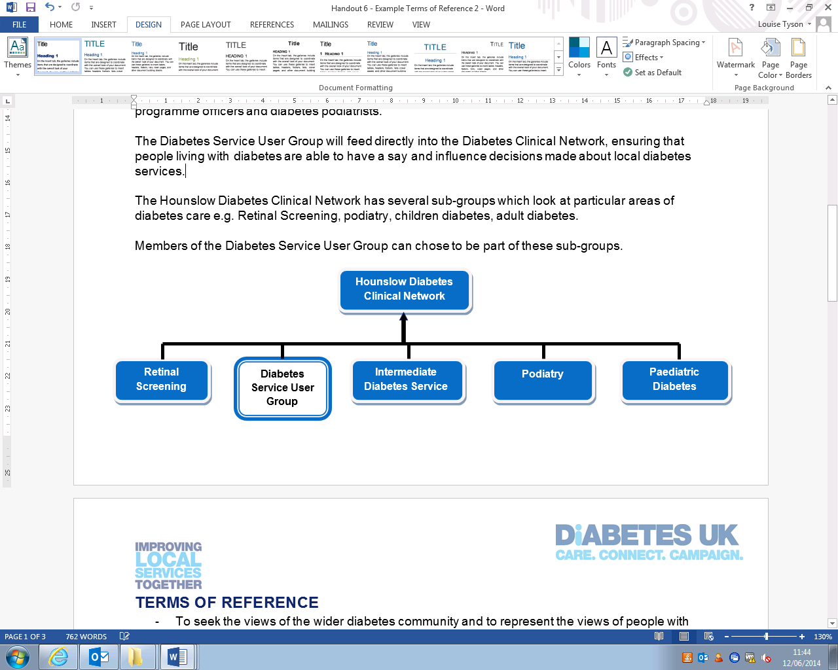

### **Terms of reference**

* To seek the views of the wider diabetes community and to represent the views of people with diabetes, parents and carers in the Hounslow area, as best as they can;
* To fully participate in discussions and make suggestions and recommendations to the Hounslow Diabetes Clinical Network on ways in which diabetes services could work better with people with diabetes
* To advise the Hounslow Diabetes Clinical Network regarding priorities and areas of concern of Diabetes service users in Hounslow;
* To attend meetings of the Hounslow Diabetes Clinical Network, providing the diabetes service user views.

**Membership**

To be considered for membership to this group you must:

* Have diabetes, or be a parent or carer of somebody with diabetes;
* Receive NHS care within the Hounslow area;
* Reflect the diversity of the diabetes population in the Hounslow area;
* Represent a mixture of experience of different diabetes services

Membership of the group will be reviewed on an annual basis and refreshed to ensure that it continues to be representative of people living with diabetes in the Hounslow area. Hounslow CCG will have the power to suspend or terminate membership of any member in consultation with the group if considers that a member is no longer able to affect the group’s ability to fulfil its aims.

### **Support**

The group will be supported by Hounslow Clinical Commissioning Group. They will ensure that appropriate arrangements are in place to support members of the group and for the organisation of group meetings.

Members will be provided with information and training to support them in their roles, as appropriate.

### **Meetings**

* Meetings of the Diabetes Service User Group will be held on a six-weekly basis.
* The time and dates of meetings will be set in-line with the preference of group members, as far as is possible. Dates for each year will be set in advance.
* It is possible to arrange meetings via the phone (teleconference) or via Skype/Facetime to best suit the needs of the group.
* Meetings will be held in an accessible venue, in consultation with group members. Members will be reimbursed for reasonable travel expenses.
* Meetings will be initially serviced by Hounslow Clinical Commissioning Group (organising meeting dates, agendas and minutes) until the group is in a position to appoint a leading person.
* Papers will be circulated to the group one week in advance of the meeting. Any group member may propose items for the agenda in advance of the meeting.

**Commitments**

* Group members will be expected to read papers in advance of the meetings.
* Members are encouraged to attend each meeting. If unable to attend a meeting they are encouraged to submit their views in advance of the meeting.
* If a member has a continued reason for absence that member’s continued involvement will be reviewed and a replacement sought if deemed necessary.
* As well as attend the six-weekly meetings of the Diabetes Service User Group, members will also be expected to attend meetings of the Diabetes Clinical Network (which meets every two months).
* It is thought that overall this will amount to no more than 1 meeting per month.
* Members will also be invited to attend meetings of the sub-groups, for areas that they have particular interest/experience in.

Stage 2 - Recruitment

**recruiting members of an ongoing group**

If you are recruiting people to an ongoing user group or as a patient representative, you would ideally use a relatively formal process.

You will already have developed Terms of Reference for the Service User Group, and potentially have in place Role Descriptions which you would like to fill.

An Ongoing Service User Reference Group would ideally have a link into the decision-making processes for diabetes services. Or you may be looking for Patient Representatives to have a place on a decision-making group within your organisation (i.e. on a Clinical Management Board). Therefore it is important that you are able to recruit somebody suitable, who is able to make a valid contribution to these important roles.

Service users need to fully understand their role and be clear about what they are committing themselves to. So you may wish to have a relatively formal approach to recruitment. You may want to use:

* A short application form requesting some details about the person, why they want to be involved and what they think they could bring to the role. For a less formal process, you may wish to ask them just to submit a short written statement of interest in the role.
* And/or informal interviews by phone or face to face will provide a mechanism to ensure a good match. It’s good to have a conversation with people who are potentially going to be involved long-term and to ascertain how they will be able to bring the views of other people they are representing to meetings.

Not everyone will be right for this sort of role and you will need to limit numbers - it is ok to have specific criteria and to turn people down (but try to offer them an alternative way to get involved).

When you know who you are looking for, think about who can help you reach them. This will include people inside your organisation and local community groups.

**EXAMPLE APPLICATION FORM**

Depending on the role you are trying to fill, it may be appropriate to ask people to fill in a short application form. The below is an example form which you may like to use, although you may also wish to make it more informal so as not to intimidate interested people. As a minimum we suggest including the sections marked with an asterisk:

## **\*Personal Details**

|  |  |
| --- | --- |
| Name: |  |
| Address: |  |
| Postcode: |  |
| Daytime telephone: |  |
| Mobile phone: |  |
| Email: |  |

## **Your Availability**

|  |  |  |  |  |  |  |  |  |  |  |
| --- | --- | --- | --- | --- | --- | --- | --- | --- | --- | --- |
|  | Monday | | Tuesday | | Wednesday | | Thursday | | Friday | |
|  | am | pm | am | pm | am | pm | am | pm | am | pm |
| (Please tick as appropriate) |  |  |  |  |  |  |  |  |  |  |

## **\*Skills and Experience:**

|  |
| --- |
| Please outline your reasons for wanting to get involved in the Diabetes Service User Group |
| Please tell us about the skills you have and/or the personal experience that you could bring to the Service User group |

|  |
| --- |
| What do you think the biggest challenges of this role might be for you? |
| **Further Information**  The information collected on this application form is for the purposes of selecting members for the Diabetes Service User Group and will not be released for any other purposes, without seeking your prior consent. This information is confidential within Hounslow Clinical Commissioning Group. |
| Signature: Date: |

## 

## **Where did you hear about this role?**

Please return your completed application by <date> to:

<contact name and address>

Or you can email <email address>

## 

## **Equal Opportunities Monitoring**

The information in this section is used only for the purposes of ensuring the effectiveness of our Equal Opportunities Policy, which is available on request.

**Gender:**

|  |  |  |  |  |
| --- | --- | --- | --- | --- |
| Male |  |  | Female |  |

**Age group:**

|  |  |  |  |  |  |
| --- | --- | --- | --- | --- | --- |
| <20 | 21-30 | 31-50 | 51-60 | 61-70 | 71+ |
|  |  |  |  |  |  |

**How would you describe yourself?**

Using the following classifications, how would you describe your ethnic origin? (please tick appropriate box)

|  |  |  |  |
| --- | --- | --- | --- |
| Asian or Asian British: Indian |  | Mixed – White/Black Caribbean |  |
| Asian or Asian British: Pakistani |  | Mixed – White/Black African |  |
| Asian or Asian British: Bangladeshi |  | Mixed – White/Asian |  |
| Asian or Asian British: Any other Asian background: (please write in): |  | Any other mixed background  (please write in): |  |
| Chinese or Other Ethnic group: Chinese |  | White: British |  |
| Chinese or Other Ethnic group: Any other Chinese background: (please write in): |  | White: Irish |  |
| Black or Black British: Caribbean |  | White – Any other White background (please write in): |  |
| Black or Black British: African |  | Traveller – Irish |  |
| Black or Black British: Any other background (please write in): |  | Traveller – Romany |  |
|  |  | Traveller – other (please write in): |  |
| Prefer not to say |  | Don’t Know |  |

**Do you consider yourself to have a disability/impairment?**

|  |  |  |  |
| --- | --- | --- | --- |
| Yes |  | No |  |

Ifyes, please specify:

**Do you have any particular requirements that might affect your volunteering? (e.g. diet, disabilities, religion)**

|  |  |  |  |
| --- | --- | --- | --- |
| Yes |  | No |  |

**EXAMPLE TELEPHONE INTERVIEW FRAMEWORK**

|  |
| --- |
| Thank you for your interest in joining our Diabetes Service User Group. My name is XX and I work for Hounslow Clinical Commissioning Group. I’d like to have a short discussion with you to find out why you would like to be part of the group and what you think you can bring to the group. |
| **Question 1**  Can you briefly explain what you understand this role to be and what you think the diabetes user group will do? |
| **Question 2**  How do you feel about representing your views in a meeting? *(explain who else will be in the meetings).*  How would you deal with a situation where you don’t agree with someone’s opinion? |
| **Question 3**  Part of the role is about engaging with other people with diabetes and representing their views. Do you have any ideas about how you might find out what other people think? |
| **Question 4**  In your application form you identified that xxx would be your biggest challenge in the role. Can you tell us a bit more about this, and how you might deal with/overcome it? Or how we can help you to overcome it? |
| Do you have any questions? |
| If your application is successful, we will be holding an induction day/the first meeting for all members on <insert location, date and time>. Are you available/which date would be preferable for you? |
| Thank you for your time, we will be in touch by <insert time> to let you know the outcome of your application. |

**EXAMPLE RECRUITMENT PLAN**

|  |  |  |  |  |
| --- | --- | --- | --- | --- |
| **Activity** | **Lead** | **Deadline** | **Progress** | **Comments** |
| **Resources** | | | | |
| Design promotional flyer | DUK | 9 December |  | DUK to provide draft and West Hampshire to add contact details etc.  May want to slightly adapt flyer depending on audience you are going to |
| Produce copy for emails/letters to promote event and provide further information to people who are interested | DUK | 9 December |  | This will assist people dealing with enquiries or requests for more information |
| **Diabetes UK Networks** | | | | |
| Emails and calls to people on DUK database | DUK | Ongoing until 31 January |  | DUK to make contact and ask people who are interested if they are happy for their contact details to be shared with W Hants |
| Contact Diabetes Voices and Services Champions in the local area | DUK | 11 December |  |  |
| Promote via Diabetes UK South-East Regional Manager and Volunteer Development Officer | DUK | 11 December |  |  |
| Promote via local DUK voluntary groups | DUK | 11 December |  |  |

|  |  |  |  |  |
| --- | --- | --- | --- | --- |
| **West Hampshire CCG Networks** | | | | |
| Patient Participation Groups:  Contact and ask them to promote the event to their networks | W Hants | 13 December  15 January |  | Because of the timings, it would be helpful to do some more work in the New Year to remind people of the events |
| Contact any groups of patients with diabetes who West Hampshire CCG have engaged previously | W Hants | 13 December  15 January |  | Contacting people by phone and having a conversation with them to explain what you are trying to do is usually most effective |
| GP practices | W Hants | 13 December  15 January |  | * Place flyers in reception; * Notice on electronic display boards/ notice boards; * Brief GPs, Practice Nurses, DSNs to tell individual patients about event and hand out flyers; * Spend some time speaking to patients in the waiting rooms |
| Local Hospitals:   * Promote at Diabetes Clinics | W Hants | 10 January |  | Attend clinics if possible and speak to patients as they are waiting |
| **Online** | | | | |
| Inclusion on the CCG website | W Hants | 8 January |  | List event on the ‘Get Involved’ section of the website |
| Social media | DUK/ W Hants | 8 January |  | * Promote event on Twitter – encourage local organisations to tweet about the event e.g. @WestHantsCCG * Diabetes UK social media team to tweet event |
| Online community forums: | W Hants | 8 January |  | Research local online forums and promote the event there, if appropriate |
| **Other networks** | | | | |
| Local pharmacies | W Hants | 13 December |  | Contact and ask them to hand flyers to any people with diabetes collecting prescriptions |
| HealthWatch Hampshire | W Hants | 13 December |  | Ask them to promote to members via their website and newsletters |
| Advert in local newspapers and/or on local radio | W Hants | 10 January |  | You can usually insert free adverts in local papers to promote community events – or failing that issue a press release so that it goes forward as a news item |
| Community groups and local faith organisations   * Carry out some research into local groups and organisations; * Contact them, explain what you are trying to do and ask them to promote it to their contacts/members | W Hants | 10 January |  | The local Council for Voluntary Service (CVS) or the Local Authority may be able to provide you with details  Building relationships with community organisations can take time and perseverance! |
| Other things to consider:   * Shoe shops? * Shopping centres/ major supermarkets * Major employers? | W Hants | 10 January |  |  |
| Other groups to contact: | W Hants | 10 January |  |  |
| **Winchester Area Community Action:** <http://www.waca.org.uk/> - WACA is the Council for Voluntary Service supporting voluntary and community activity in the Winchester District area.    **Community Action Hampshire (Based in Winchester but based all over Hampshire):** <http://www.actionhants.org.uk/> - Independent county-wide support and development organisation for the Not-for-Profit sector in and around Hampshire.  **Community First New Forest:** <http://www.cfnf.org.uk/> - Active charity based around improving lives for people and communities living in the New Forest District and surrounding districts    **Directory for services in New Forest Area -** <http://www.cfnf.org.uk/PDF_Files/2013/New_Forest_Directory_of_Services.pdf>  **Asian Welfare & Cultural Association:** <http://www.awca-eastleigh.org.uk/> or Tel 07817 800846– Group focused on the minority Asian Community in Eastleigh    **Ford Community Association (CFCA):** <http://www.cfca-rmh.org.uk/> - Community centre and group    **1 Community:** <http://www.1community.org.uk/pages/home.aspx>or [lsams@1community.org.uk](mailto:lsams@1community.org.uk) or 023 8090 2404 – The Hampshire CVS | | | | |

**EXAMPLE RECRUITMENT FLYER**

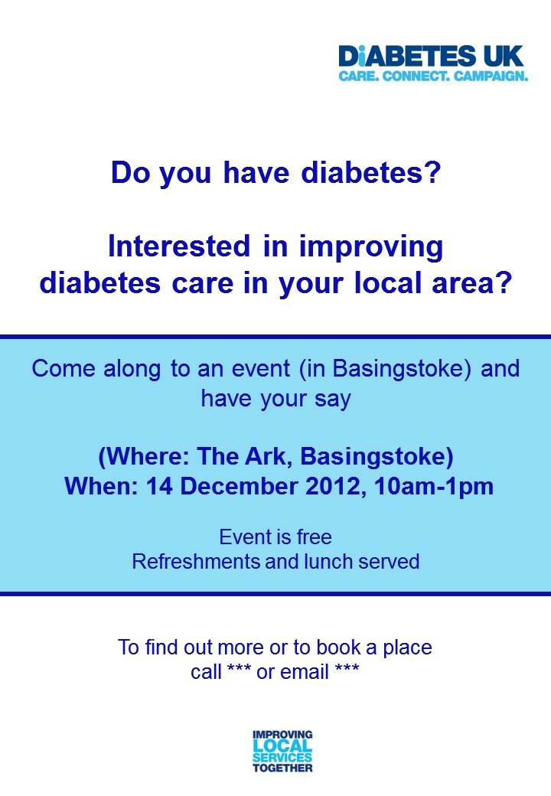

Consider leaving out a key detail (e.g. venue) to force people to contact you for more info - so you know who’s registered.

It’s important to have a named contact and to provide different ways for people to contact you.

Give the reader something to answer ‘yes’ to so you’re off to a good start.

Stage 3 - Deliver

**EXAMPLE FACILITATION PLAN FOR AN ENGAGEMENT EVENT**

|  |  |  |  |
| --- | --- | --- | --- |
| **Time** | **Activity Notes** | **Resources** | **Lead** |
| 9:00-9:45 | **Set up**   * Registration table including attendance list for sign in, name labels and any participant hand-outs * Tables set up (cabaret) – pens, sheets of flip chart and post-its * Check refreshments are set up and confirm catering arrangements for the day * Check signage for the room * Set up ‘Park it’ wall * Check venue details e.g. location of toilets and fire drill | Registration list, pens (biros and markers), blank labels, programmes, other participants hand-outs, post-it notes. | DUK |
| 9:45-10:00 | **Participant registration**   * Refreshments served |  | DUK |
| 10:00-10:10 | **Welcome and introductions**   * Thank you for coming * Introduce team * Explain purpose and format of day: * *DUK and North Hants CCG are working together to ensure people living with diabetes get a say in the future delivery of services. North Hants CCG is the new commissioning organisation in your area. They are looking to improve diabetes care by redesigning services and the way care is provided, so this is your chance to have a say before these changes happen.* * *The first session is going to give you a chance to find out about some of the work the CCG is doing around diabetes services. There will be lots of chances for you to comment and ask questions. We then want you to tell us a bit about what you think of the care you are receiving at the moment – what could make it better/easier for you, and what is working well. This will help influence the work of the CCG going forward.* * *Does that sound ok? Any questions so far?* * Housekeeping: * *Fire alarm* * *Toilets* * *Lunch is scheduled for 1pm, with a refreshments break at 11:20, but today is an informal session so feel free to get up and stretch your legs or grab a drink if you need to.* * Golden rules: * *We have a few golden rules that we’d like to share with you, these are for all of us.* * *Share your experiences, participate, respect others, say it in a minute, ask questions, mobiles on silent, keep to time, enjoy yourself!* * *Anything you want to add?* * Explain ‘park it’ wall: * *We’ve got a lot to get through today, so at some points we might ask you to hold that thought and write it down on the post it note. You can do the same with any other comments you have today that you don’t get a chance to say. You can then stick it on the park it wall and we will have a look at them all afterwards.* | Golden rules written up on flipchart paper at the front. | DUK (AD) |
| 10:10-10:20 | **Ice breaker**   * *Before we get going, we’ve got a quick ice breaker to help us all get to know each other a bit better.* * *You should each have a sheet with a number of statements on it. The aim is to find someone in the room who can answer yes to each statement. Get as many different names as possible – start on your table and then you can start moving to other tables too – you can also ask us!* | Ice breaker worksheet | DUK (KW) |
| 10:20- 10:40 | **Presentation on the work of the CCG and diabetes redesign work**   * Briefly explain who you are and what the role of the CCG is * Present the new proposed model of care – explain different elements, how it fits together and how you feel it will help improve care * Focus on the elements that you feel people with diabetes can influence – which parts do you want their feedback on? * Allow time for comments and Q & A | Laptop and projector (if using PowerPoint) | North Hants CCG (CC) |
| 10:40 – 11:00 | **Discussion 1 - Your opinions of current care**   * Table discussions about the positive and negatives aspects of the current care they receive. * *It’s now your turn to do most of the talking! This is a chance to tell us what you think of current care.* * *First you’ve got ten minutes to discuss ONLY the positive things about the care you currently receive. If you can’t think of anything positive, you can’t say anything!* * *You’ll then have ten minutes to discuss ONLY the things that you think could be improved.* * *Someone on each table needs to take some notes on the flipchart – just remember, the person with the pen has power. Don’t abuse your power!* | Flip chart and pens on each tables | DUK to lead (KW)  All to facilitate tables |
| 11:00-11:10 | **Feedback from discussion 1**   * Each table to feedback top three positive and top three negative. |  | DUK |
| 11:10 – 11:30 | **Discussion 2 - What do you want from services?**   * Table discussion about what participants need from services to help them better manage their diabetes * *What services to you want/need access to?* * *How would you access services?* * *Where would you go?* * *How would they link up?* * North Hants CCG to explain context * Group to capture discussion on flip chart and map out a ‘perfect diabetes service’ | Flipchart paper and pens | North Hants CCG  All to facilitate tables |
| 11:30-11:45 | **Refreshment break** |  |  |
| 11:45 – 12:00 | **Discussion 3 – What would help you better manage your diabetes?**   * Fifteen minutes for groups to discuss what tools, resources and support they need to help them with self-management e.g. patient information, education courses, support groups, websites * Explain context * Groups have fifteen minutes to discuss and prioritise their ‘top 3’ | Flipchart paper and pens | North Hants CCG |
| 12:00 – 12:10 | **Feedback from discussion 3**   * Groups to feedback their ‘top 3’ |  |  |
| 12:10 – 12:20 | **Website**   * 10 minute full group discussion on specific questions relating to the website: * *Would you access a local diabetes website?* * *If so, what information or resources would you like to see on a local Diabetes website?* * DUK/North Hants CCG to capture flip chart notes at the front |  |  |
| 12:20-12:30 | **Wrap up**   * Final comments from participants * Explain next steps and feedback * Evaluation form * Thank you! |  | DUK (AD)  North Hants CCG (WC) to provide info on next steps |
| 12:30 | **Lunch** |  |  |

**Other Examples of Session Structures**

**LOOKING AFTER YOUR FEET**

Table discussion about looking after your own feet, and resources and information required to be able to do this. Notes captured on flip chart.

* *What do you need to be able to look after your own feet? What information and resources do you need?*
* *Are the example leaflets helpful? Which one/what elements do you like best?*
* *What, if anything, is missing?*
* *Do you know where to go if there is a problem?*
* *Would you use information on a website? What do you think of the use of videos to help?*

Groups to prioritise ‘top 3’ things they need to look after their own feet

**AN IDEAL DIABETES SERVICE**

Table discussion about what an ideal diabetes service would look like in South Lincolnshire. Ask groups to map the service out on flipchart.

* *Where would you like to go to access services?*
* *Who would you see and how often?*
* *What other support would be offered by South Lincolnshire CCG?*

**STRUCTURED EDUCATION**

Existing education:

* *Did you know that you could attend an education course about diabetes? X-PERT – group education over 6 weeks, covering a range of different topics about diabetes (raise of hands ‘Yes’ or ‘No’)*
* *At some point you have all been referred by your GP to attend an education course. Were you aware of this?*
* *Reasons for not attending*
* *(CLCH to provide some brief information about the course) Now you’ve heard a bit more about it, does this sound of interest to you? Or not? Why?*

‘Ideal’ education:

* *What kind of education would work best for you?*
* *What would make it easier for you to attend an education course?*
* *Practical issues – when? How often? Where? For how long?*
* *What topics would you want to see covered in an education course?*
* *Suggestions for alternative approaches*
* *Would you prefer a shorter course? A taster version?*
* *Would you prefer an online version?*
* *Would you prefer 1 to 1 education?*

**Example telephone interview framework**

|  |
| --- |
| **Introduction**  Thank you for agreeing to take part in this interview. My name is Louise and I work for Diabetes UK. We are conducting some work with West Hampshire CCG to capture the views of local people with diabetes, regarding their experiences of local care and what they would like to see improved. In particular they are focusing on foot care services  Everything you say today is said in confidence, so you can be open and honest with your views. Your name will not be revealed to anybody, so anything you say will not be attributed to you personally. This telephone interview will last around 15 minutes or so.  Do you have any questions before we start? |
| **Warm up**   * Please introduce yourself (name, where the patient lives, occupation) * Tell me what your favourite thing to do during your free time is * Type of diabetes and how long since diagnosis * What is your GP practice |
| **Question 1**  What do you think are the best things about foot care in West Hampshire in your experience?  What, if anything, would you like to see improved about foot care in West Hampshire in the future? |
| **Question 2 – In an ideal world.....**  How would you like to access foot care services? Where would you like to go? E.g. GP Practice, a specialist diabetes clinic in the community or the hospital  What would make it easier for you to attend foot care appointments? E.g. would you like to be able to go to evening appointments, or weekends?  Is there any support you feel you need that you don’t currently get in your area for your diabetes care regarding your feet? |
| **Question 3 – Self Management**  What support or information have you been given about looking after your feet?  What support or information would you like to be offered?  What else would you like to see to help you self-manage your condition? |
| Is there anything else that you would like to say about diabetes services, that we haven’t already covered? |
| Thank you for taking the time to speak to us today, it has been very helpful. We will be collating the responses from each of the interviews and focus groups that we’re carrying out and the information will be used to help West Hampshire CCG design diabetes services for the future. We or they will send you details of all of the feedback in the near future  Thank you again for your help. Do you have an email address that we can send the feedback to you on?  **Close** |

**CHECKLIST for an engagement event**

**REFRESHMENTS**

Ensure refreshments are available on arrival, and throughout the day. Remember to ask participants if they have any dietary requirements in advance. Ensure refreshments are suitable for people with diabetes and that there is choice; if you are providing biscuits, provide fruit too, and remember to provide sweetener as well as sugar. A sandwich lunch is fine and can work as an incentive for people to attend! If possible, show carb content labels on food and be aware of the sugar content of foods, for example mayonnaise in sandwiches.

Let people know beforehand if food will be available and at what times you’ll be providing them so they can plan their meals ahead.

**STAFF**

Ensure that you have sufficient staff available on the day and they are all briefed about their roles in advance. Ideally, this would include a lead facilitator, a co-facilitator (or 2) to help with table discussions and break out groups, and someone with responsibility for logistics and ensuring everything runs smoothly (including registration, resources and refreshments). It is also important to have someone present from the project team (if different to those facilitating the event) to field any questions about the purpose of the work and how the activity will help inform plans for the services.

We also find that patients like to have a Healthcare Professional present on the day to direct questions to. However it is important that the Professional understand their role (it can be easy for them to be bogged down with answering questions about individual’s care!). On the other hand, too many professionals being present may be intimidating to some and restrict how open they are willing to be about local services.

**COMFORT**

Be aware of the temperature in the room and make sure you have checked out the heating system so you know how to change this easily if needed. Make sure that there are at least some chairs with arms as some people may need these. Also be conscious of how loud it will be in the room with people speaking and if it’s possible, make plenty of room between tables. If you have a chance, visit the venue prior to the event to check its suitability.

**ATTENDEES**

A couple of days before your involvement activity it is a good idea to contact those that have registered to attend. This will serve as a reminder to them that the session is going ahead and is an opportunity for them to ask any questions they have about the session. Make sure people know how to get to the venue by including a map with emails or letters, or offering to send one on. If you can, try to telephone people – they are likely to feel like they’ve made more of a commitment and are more likely to attend the session.

Remember there is still a possibility that you have a low turnout on the day. But try not to let that knock you off of your stride or to show your disappointment. Focus on those that are there, rather than those that aren’t – as those people have still given up their valuable time

**RESOURCES**

**Stationery**

* Flip chart paper – venue may be able to provide
* Note paper for participants
* Marker pens for flipchart paper (black is usually more visible for those with sight problems)
* Normal pens
* Post-it notes – lots/different colours!
* Blu-tack
* Stickers for name labels

**Equipment**

* Laptop / memory stick for PowerPoint slides
* Projector – venue should be able to provide
* Extension lead

**Participant resources**

* Programmes
* Hand outs
* Ice breaker
* Expense claim forms
* Relevant information leaflets (appropriate to the event topic)

**Facilitator resources**

* Attendance list including special and dietary requirements
* Sign in sheet for attendees
* Copies of Facilitation plan (see DUK Template)
* Signposting for entrance
* Evaluation forms (see DUK template)

**Other**

* Hypo kit (lucozade/glucotabs)

**Example evaluation form for engagement event**

1. **What was your overall impression of the day? Please circle up to five of the terms below that best described the session**

|  |  |  |  |  |  |  |  |  |
| --- | --- | --- | --- | --- | --- | --- | --- | --- |
|  | | |  | |  | |  | |
| too  long | interesting | | helpful | | awful | |
| intellectual | too  complicated | | good | | fun | |
| indifferent | practical | | waste  of time | | stimulating | |
| disorganised | exhausting | | challenging | | nothing  new | |
| well  presented | exciting | | rubbish | | insightful | |
| valuable | changed  my life | | basic | | boring | |

1. **How was the Facilitator’s handling of the day? Please circle**

|  |  |  |  |
| --- | --- | --- | --- |
| Excellent | Good | Adequate | Poor |

Any comments_____________________________________________________________________

1. **Do you feel you had your say today? Please circle: YES NO**

Please add comments:

_______________________________________________________________________________

_______________________________________________________________________________

1. **What was your favourite thing about today?**

_______________________________________________________________________________

_______________________________________________________________________________

1. **What was your least favourite thing about today?**

_______________________________________________________________________________

_______________________________________________________________________________

1. **Any other comments**

_______________________________________________________________________________

_______________________________________________________________________________

_______________________________________________________________________________

1. **How would you rate the refreshments, venue and facilities? Please circle**

|  |  |  |  |
| --- | --- | --- | --- |
| Excellent | Good | Adequate | Poor |

Any comments_____________________________________________________________________

_______________________________________________________________________________

**Thank you very much for completing this evaluation.**

Stage 4 - Review

**FINDINGS REPORT FOR A USER INVOLVEMENT ACTIVITY – EXAMPLE STRUCTURE**

## *NB. When sending the report out to service users, ensure that you shorten the report and only include the background, key themes and actions to be taken. Also include a ‘future involvement’ paragraph at the end of the report to thank them for their input and inform them of further opportunities.*

**BACKGROUND**

A short paragraph giving a brief summary of the activity, why it was held, by who and the general focus of the session.

*For example:*

*Central London Community Healthcare (CLCH) Trust are working with Diabetes UK to give local people with diabetes a chance to influence the diabetes services that they receive. In June and September 2013, 3 focus groups were held to explore people’s general views of services and structured education programmes, to feed into CLCH’s work to improve access and take-up to their X-PERT programme. In addition to this, 30 telephone interviews were held with individuals to capture a wider number of views. This report presents the findings from the focus groups and interviews.*

**METHOD**

Describe the process followed on the day for the individual sessions. Include who facilitated and, if applicable, who presented on the day. Set out the key questions that were asked of participants, and how feedback was captured (e.g. through whole-group or table discussions, participants writing ideas down)

*For example:*

*Each of the focus groups were jointly hosted by Diabetes UK and Central London Community Healthcare Trust, with Diabetes UK’s Improving Local Services Together project team leading the facilitation and the note-taking. The groups were also supported by Martin Jones, Diabetes Dietician from CLCH. Three key questions were addressed within the focus group, which each lasted around 90 minutes:*

* *What do you think of the diabetes care that you currently receive (positive things and things that could be improved)?*
* *What would make it easier for you to attend an education course?*
* *What would an ‘ideal’ education course look like?*

**PARTICIPANTS**

Outline who attended. Include, if possible, the demographic profile of the attendees in terms of the diversity of the participants and how representative it was of the overall population of the area. You may also wish to briefly explain how people were recruited, and the attendance rate (proportion of those registering in advance who attended).

*For example:*

*3 Focus Groups were held, one in each of the London Boroughs of Westminster, Hammersmith and Fulham, and Kensington and Chelsea. Around 100 diabetes patients living in each area were written to, inviting them to attend the relevant focus group session. Participant attendance was as follows:*

* *Westminster Focus Group, 10 June 2013 – 14 people signed up for the focus group, and 7 attended. 2 participants left partway through the focus group due to a misunderstanding of what would be discussed on the evening*
* *Hammersmith and Fulham Focus Group, 18 September 2013 – 8 people signed up with 7 people attending*
* *Kensington and Chelsea Focus Group, 23 September 2013 – 8 people signed up with 5 people attended*

*In all, there were 19 participants to the focus groups. 11 of the participants were male, and 8 were female. In terms of ethnicity, 5 were White-British, 5 were Black-African, 5 Arabic, 3 Afro-Caribbean and 1 Pakistani.*

**KEY THEMES**

Short analysis of the findings form the activity (around 1-3 pages, depending on the activity). This shouldn’t be just a word-for-word account of what was said. Pick out the key themes that came up regularly through the activity and summarise the main points.

*For example:*

*The below summarises the key themes arising from the focus group discussions and from the interviews. Full details of the findings from all focus groups and the interviews can be found as an appendix to this report:*

***Supportive Health Professionals***

*Generally people were very pleased with the diabetes care that they were receiving locally. The participants all had experience of accessing services in a variety of locations across the area, but agreed that they were pleased with the general standard. In particular it was said that people are treated as individuals and given time to talk to health professionals about their concerns (‘it seems like the nurses really care’. ‘They are supportive and listen to my needs’). A number of people also said that they were pleased with the quality of advice that they get from professionals in relation to managing their own condition.*

*Despite this there were a number of areas that participants felt could be improved. A common issue across services was the long wait for appointments. This was in two respects: firstly, the waiting time to receive an appointment and secondly the delay in the appointment actually starting once the patient is in attendance. An example of one patient having to wait for up to two hours for their appointment was cited. Another complaint was that in one particular area the patient had to remind the practice that they were due their check.*

***Access to a Dietician***

*Another area for improvement that was raised was regarding dietary advice. Participants felt that they would like more information and guidance about their diet, while one participant also felt that the advice they received from a non-diabetes specialist dietician was not helpful (‘advice wasn’t specific or tailored enough to me’), and another participant commented that the advice they received from their GP conflicted with what they were being told by a dietician. General access to a dietician was an issue that came up on a number of occasions as something that people wished to be improved. People found that being able to see a dietician after diagnosis to be extremely useful, but would like to have access beyond that initial period.*

**ACTIONS TO BE TAKEN**

Explain the next steps to be taken after gathering the information. Set out who the detail will be shared with, and how the information will be used to influence future service provision. At the time of writing the report, it’s unlikely that you’ll be able to be specific on what action will be taken – although you may wish to revisit the report once the actions for improvement have been agreed on, and outline what has been done as a result of the involvement activity. This could be done in a ‘You Said, We Did’ type approach. Within this, try and say what you haven’t done – be clear why these ideas are not appropriate or possible to implement at this time.

*For example:*

*The results of the engagement sessions will be shared with participants of the events, secondary care, community providers, GP practices within the boroughs, and the Diabetes Working Group. The information gathered will be used to inform CLCH’s work to develop a self-management model. The findings will also be used to review the current Structured Education course to commission a more accessible course in the future. In the meantime CLCH will explore alternative venues for the delivery of the X-PERT programme in Hammersmith and Fulham and the possibility of hosting an evening session in the borough.*

**APPENDIX**

Include the typed-up notes from the involvement activity as an appendix. This will show participants that their comments were listened to and considered, even if they have not been reflected in the themed summary earlier in the report. It may also provide useful additional detail to commissioners/decision-makers.

**EXAMPLE FEEDBACK FOR PATIENTS**

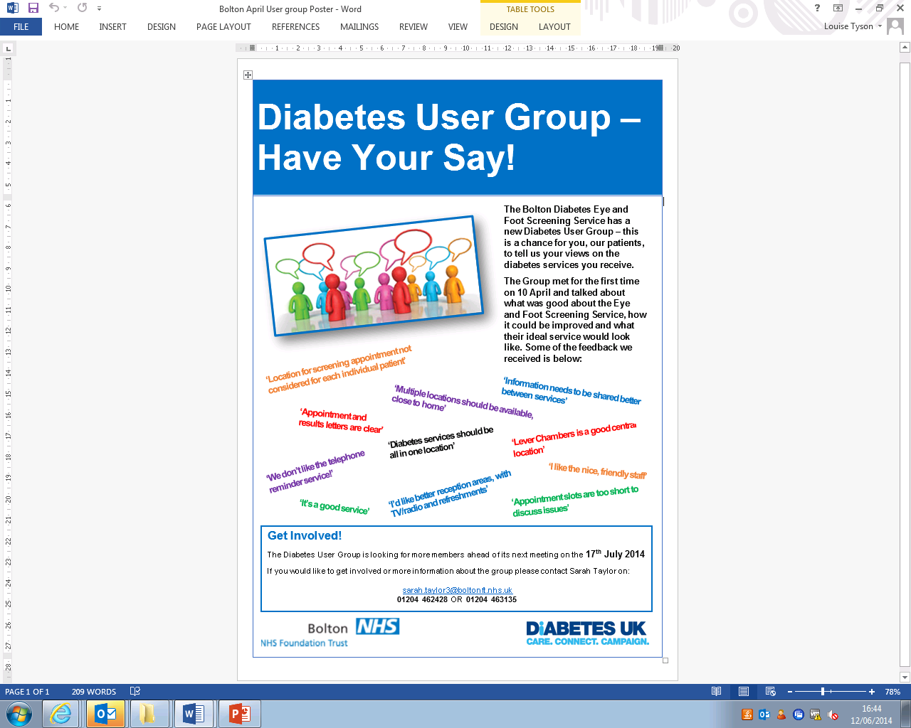

**CASE STUDIES – USER INVOLVEMENT IN DIABETES SERVICES**

**NHS NORTH HAMPSHIRE CLINICAL COMMISSIONING GROUP**

## **Background**

North Hampshire CCG identified diabetes outcomes as a key priority for the area. They have redesigned their care pathway to move towards patients being able to access the majority of diabetes services from within community based settings, and ensuring that all services meet the NICE quality standards. In November 2012 the CCG approached Diabetes UK to support them in some engagement activities to capture their perspectives on how services could be better and test whether the new proposed model would work

## **Approach**

To fit in with the CCG’s timescales for signing off the proposed care pathway we arranged to hold a joint-event in December 2012, leaving five weeks to recruit service users to attend the session. Diabetes UK sent emails and letters to people within their own contact database. This helped to build awareness of the session, but follow-up phone calls to a large number of people proved to be successful in persuading people to register and attend on the day. The CCG also promoted the sessions through a number of different routes. They distributed flyers to each GP Practice in the CCG as well as the diabetes clinics within hospitals (although this didn’t prove to be very effective in picking up registrations for the event). More successful though was the time that a representative of the CCG spent talking to patients in the waiting area of diabetes clinics at Basingstoke and North Hampshire Hospital, and making contact with the local Council for Voluntary Service. Through this the CCG were able to make contact with a community leader within the Nepalese community in North Hampshire. The community leader agreed to mobilise a group of people with diabetes from the local Nepalese community to attend the session and arrange an interpreter to enable them to contribute.

45 people with diabetes attended the session, including a group of 10 representatives from the local Nepalese community. The attendees were split into tables of approximately 6 people and, after a short introductory presentation from the CCG about the new proposed model for diabetes, were asked to consider the following:

* General opinions of current diabetes care (positive and negative)
* What do people need from current services, what would they like to access and where/when?
* How can the CCG support patients to better self-manage (including a specific discussion on a diabetes website)?
* Personalised Care Planning, and how users think this may help them

## **Findings and Actions Taken**

The key themes that emerged from the event were that the intentions to bring services into the community was a good idea – however more education for people living with diabetes was needed to help people self-manage and increase understanding of the condition. People also felt that the provision of psychological support for people with diabetes was currently insufficient and more should also be done to assist family members of patients. Attendees broadly supported the idea of a diabetes-specific website, and welcomed more input into their care through personal care plans.

The CCG gained valuable information on people’s experiences of local diabetes services, and their views on the proposed pathway which has influenced the way that services have been re-designed. The Clinical Commissioning Group have also committed to involve service users on a more ongoing basis in the future. Following this initial event the CCG has maintained the network of service users to notify them of future opportunities to get involved and have their say.

In November 2013 Diabetes UK worked with North Hampshire to host a focus group for 12 people with diabetes to look in closer detail at some of the themes raised earlier. In particular a proposed layout for a new diabetes website was shared with people for their views on the appearance, as well as what content they would like to see. Attendees felt that the information available should be clearly marked where it is targeted at patients or health professionals – but that all of the information should be available to everybody so patients can look at the rest if they are interested.

Attendees also discussed the CCG’s proposed approach for a diabetes Structured Education programme for Type 2 diabetes, Conversation Maps. The approach was liked by the attendees, but a number of other concerns were raised which the CCG agreed to consider. These were primarily about the practical elements of the course, such as the times of days and the locations that the course would be available. Also the importance of refresher sessions being on offer and ongoing action planning with health professionals was raised.

North Hampshire Clinical Commissioning Group have used the feedback and ideas received from service users to adapt the diabetes website and the structured education programme and both have now been launched.

**NHS MEDWAY CLINICAL COMMISSIONING GROUP**

## **Background**

Medway Clinical Commissioning Group are working to implement an integrated service approach for diabetes care with the aim of standardising care so that people with diabetes can be seen in the right place, at the right time, by the right person. A key part of the project work was to develop the annual review and care planning process to ensure it fulfils the needs of the patient. Medway CCG approached Diabetes UK to work with them to develop an effective mechanism to enable people living with diabetes to influence the service redesign work being undertaken by the CCG.

## **Approach**

Although Medway CCG had captured a range of information to set a baseline for their current diabetes services, there was a gap in knowledge of what people with diabetes thought about the services they received in the local area and how they could be better supported to manage their condition. Medway were keen to engage as many diabetes patients, and parents and carers of people with diabetes as possible in a discussion about local services.

Medway decided to hold two service user involvement events in June 2013 to gather details of people’s experiences in accessing diabetes services and their opinions of the care. Attendees were asked:

* Opinions of current care – 10 minutes on positive things, and 10 minutes about what could be improved
* Their experience of diagnosis of diabetes
* What an ‘ideal’ diabetes service would look like
* How the CCG could support them to manage their condition better

The sessions were held in different parts of the CCG locality, with one being on a weekday afternoon and the other on a weekday evening. The sessions were promoted through a variety of routes including through GP surgeries; hospital waiting areas; articles in the local press; invitations to Diabetes UK contacts; and Kent Health Watch. As well as this the CCG were successful in negotiating with local pharmacies, that if the CCG provided the leaflets then they would place them in with diabetes patients’ prescriptions when they were distributed.

63 people attended the sessions to provide their views and make the most of the opportunity to influence the work of the CCG.

## **Findings and Actions Taken**

A key finding from the involvement events was that many people felt that the level of knowledge of diabetes amongst healthcare professionals was extremely variable and dependent on where you receive your diabetes services. A number of patients commented that they did not receive an annual check of their feet, and that signposting and access to podiatry services was very poor. Structured Education programmes was also a major talking point at both events. Those that had been on a course were very complimentary of it, however the vast majority of attendees has not been offered or heard of the courses available. People also suggested that a refresher course for those that had already been on the programme or had been diagnosed for a number of years would be really valuable.

As a result of the feedback, Medway Clinical Commissioning Group put in place a number of changes:

* Training sessions for GP’s practice nurses around the Personalised Care Planning process were introduced;
* Education sessions for GP’s around developments in diabetes care and, more specifically, details of Medway’s diabetes pathway were delivered. The CCG intranet site was also revamped to include a raft of information about diabetes, including referral routes and forms, published care pathways;
* Funding was secured to expand the Diabetes Patient Education Programme. This included more sessions of the DESMOND course, as well as new sessions for people with Type 2 diabetes requiring insulin. Refresher courses for previous attendees of the programme were also introduced

The CCG also committed to a number of further actions to be taken in the long-term, including:

* Improving the information on the CCG website for patients about diabetes services;
* Improve the information available at GP surgeries and increase the number of them that have diabetes-related leaflets on-site;
* Develop information packs for newly diagnosed people with diabetes with the details they need to manage their condition, information about the condition and the support they can expect to receive from health services.

Medway Clinical Commissioning Group have established a service user reference group to provide a sustainable mechanism for allowing people living with diabetes to feed into the CCG’s ongoing improvement work for Diabetes services. The CCG was able to use the initial engagement events to gauge interest in being involved in the Diabetes User Group. Role descriptions for members were written to identify the key attributes needed of group members and what would be expected of them. After discussions with interested people to assess their suitability for the group, an induction session was held with selected service users to provide them with the information and support they need to contribute to the group. The group is now meeting on a bi-monthly basis and helping the CCG in their plans to review the Structured Education Programme to ensure that it is appropriate and accessible for service users. The CCG are continuing to look at the group to ensure that membership is representative of the whole diabetes population.

**NHS WIGAN BOROUGH CLINICAL COMMISSIONING GROUP**

## **Background**

Wigan Borough CCG are working to introduce an integrated approach to care for diabetes services, with the aim of bringing services closer to the community. The first phase of the redesign programme was a review of the current services. Diabetes UK worked closely with Wigan Borough CCG to provide opportunities for people with diabetes in the area to give their views on current local services and what they would like improved.

## **Approach**

In February 2014 we held a public drop-in session for people living with diabetes in Leigh, over three hours on a Saturday morning. To encourage more people to attend the event we invited a number of diabetes services to the session to provide information and advice to patients on different aspects of their care. This included:

* Health Trainers giving lifestyle support and advice
* Dieticians providing healthy eating advice
* Specialist nurses providing blood sugar checks and general advice
* Podiatry service
* Diabetes UK providing information about local support and information for patients

Over 100 people attended the session at some point during the day. The offer of a range of different services for users to speak to and learn more about proved to be quite an incentive for people to attend. Attendees were also encouraged to stay to enjoy some refreshments, where there were people from Diabetes UK and the CCG on hand to chat to them about their experiences of care and how they think it could be improved on a one-to-one, informal basis. We were able to speak to around a third of all attendees directly using this method. A paper questionnaire about diabetes care was also available for attendees for those that preferred to share their views in this way.

## **Findings and Actions Taken**

The main findings from the session will be fed into the CCG’s review of diabetes services and will inform their re-design of diabetes services and, where appropriate, the re-specification of those services that have been identified for improvement. A key finding from the drop-in session was that people felt that there wasn’t enough information available on diabetes services and how to manage the condition. The majority of people had not attended (or, in many cases, heard about) a structured education course about diabetes.

In partnership with Diabetes UK, Wigan Borough CCG organised a further event for people living with diabetes was arranged in a different part of the area covered by the Clinical Commissioning Group. The event was split into three different sections:

* Morning session including presentations from a range of diabetes services – aimed at increasing attendees awareness of what is available and what they should be accessing
* A ‘market-place’ area over lunchtime for attendees to visit stalls run by different local services to talk to people and find out more information
* Facilitated table discussions in the afternoon to find out what people want from a diabetes structured education programme and how it could be made easier for people to attend sessions

**NHS KERNOW CLINICAL COMMISSIONING GROUP**

## **Background**

NHS Kernow is the Clinical Commissioning Group for Cornwall and the Isles of Scilly. The CCG are undertaking a number of service improvement projects to improve care for patients with long-term conditions, including diabetes. In particular they are reviewing their foot care pathways with the aim of reducing their amputation rates. Diabetes UK worked with the CCG to engage with their diabetes patient population to take into account people’ opinions of what could work better concerning foot care.

## **Approach**

In April 2014 we jointly hosted 3 patient focus groups in different areas of Cornwall, one of which was held in the evening to enable those that worked to engage. The aim was to capture the different experiences of people living with diabetes to help influence the CCG’s review of the foot care pathway. The focus groups explored people’s general feeling about foot care in Cornwall (including what they liked and what could be better) and what information people need in order to look after their own feet better.

The events were promoted through different health services in the area, and Diabetes UK also wrote to contacts that they know in the area. However initial take-up to the focus groups was slow. Diabetes UK got in touch with a number of different local groups to help us promote the sessions. As a result of making contact with a variety of groups, several of them agreed to circulate details of the events to their members and wider network. These included the Cornwall Voluntary Sector Forum, the East Cornwall Council for Voluntary Services and some community centre venues. Health Watch Cornwall also included information in its newsletter and tweeted about the sessions. This led to over 40 people attending the focus groups.

Many people that we had contacted could not make the dates that had been arranged, but were interested in sharing their views. Diabetes UK undertook telephone interviews, or collated feedback via email for a further 10 people to help capture wider experiences.

## **Findings and Actions Taken**

The main findings from the different involvement activities included:

* Some patients were not receiving foot checks, while some others felt that the checks they did receive were not thorough enough or explained properly to them. People also stated that they would like to receive foot checks on a 6-monthly basis rather than annual;
* People would rather have all foot checks undertaken by a podiatrist rather than a GP or nurse, as they felt the specialist knowledge was crucial;
* Preferences for accessing foot care services were discussed, with people stating they would rather see centralised diabetes services where all services are undertaken at the same time. A mobile foot care service was also suggested as an alternative;
* Lack of education courses and information available to patients (on initial diagnosis and ongoing support) about how to look after their own feet and what they should be looking out for.

The findings have been reported to the CCG’s Diabetic Foot care Task and Finish Group who are leading the service improvement project. The group is considering how to take the findings from the involvement activities forward in the long-term. However they have already committed to taking the following actions in response to the issues raised:

* NHS Kernow have already organised a series of education events around diabetes aimed at doctors, nurses who work in primary care, community nurses and care home staff. There will be a foot study day in October at which the CCG will address the points raised about health professionals not listening to patient concerns and not explaining the outcomes of checks properly. The foot study day will also focus on ensuring clinicians understand how to undertake foot checks, the importance of them and where they can signpost patients for further information;
* Ensure that information leaflets (foot care-related ones produced by Diabetes UK) are available at different health care settings across Cornwall. Primarily at GP Practices where the majority of people receive their annual foot checks – but also at other locations that people access regularly such as the retinal screening service;
* Look into how NHS Kernow can improve access to primary care outside of the current core hours, to allow more flexibility for patients to attend at times that are convenient to them – such as working people. The CCG will look at develop models with local populations in venues that are accessible to provide more coordinated care for routine and urgent primary care appointments outside of current opening hours.

NHS Kernow have acknowledged with local service users that they will not be able to provide 6 monthly checks for all diabetes patients regardless of whether they have experienced foot problems. The service users that were involved in the activities have been notified that this would be too costly to introduce at this time. However the steps they have committed to take to improve information provision for patients and the understanding of clinicians should help to ensure that any emerging complications are picked up quickly in-between the annual checks.